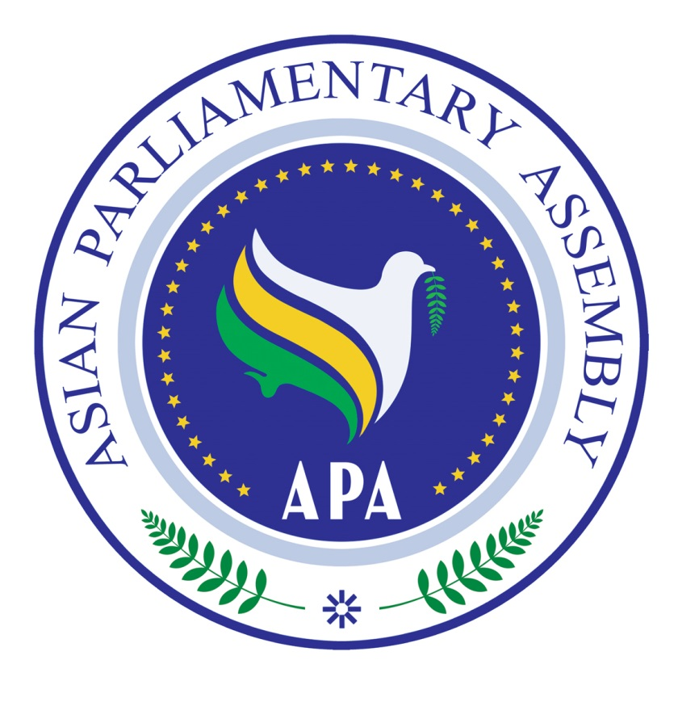

NATIONAL ASSEMBLY OF THE KINGDOM OF CAMBODIA
ASIAN PARLIAMENTARY ASSEMBLY

National Assembly

Phnom Penh, October , 2016

Dear Excellency Speaker/President

Excellency,

On behalf of the National Assembly of Cambodia and the Asian Parliamentary Assembly, it is a great honor and pleasure for us to extend a cordial invitation to Your Excellency to personally participate in the Second Executive Council Meeting and the 9th APA Plenary Session, which will be held from 28 November to 01 December 2016 in Siem Reap, Cultural Capital of the Kingdom of Cambodia.

The theme of the Plenary is “Promoting Peace and Sustainable Development in Asia”. We encourage and expect vibrant discussions and exchange of views within the context of the theme by Speakers of the APA Member Parliaments and dignitaries who are invited to participate in this very important event.

The Host Parliament will offer hospitality (accommodation, meals and local transportation) to official delegates of APA member parliaments plus one as determined in Article 8 of APA Charter, two representatives of each observer parliament and one representative of each observer organization from 27 November to 02 December 2016.

The relevant documentation of the 9th Plenary Session could be consulted at the official website: http://apa9.nac-kh.org/and the APA website: www.asianparliament.org.

The General Information and Registration Form are attached and also available on the websites. The Draft Agenda and other documents will be forwarded soon and it would be greatly appreciated if you could inform the Host Parliament and the APA Secretariat on the composition of your delegation at the earliest convenient time but no later than 20 November 2016.

It would be a great honor, if Your Excellency could lead your delegation in the 9th APA Plenary Session in Siem Reap, Kingdom of Cambodia.
Please accept, Excellency, the assurances of our highest consideration and personal regards.



Samdech Akka Moha Ponhea Chakrei, HENG Samrin M.H. Nejad Hosseinian
President of the National Assembly of the Secretary-General
Kingdom of Cambodia and APA President Asian Parliamentary Assembly

